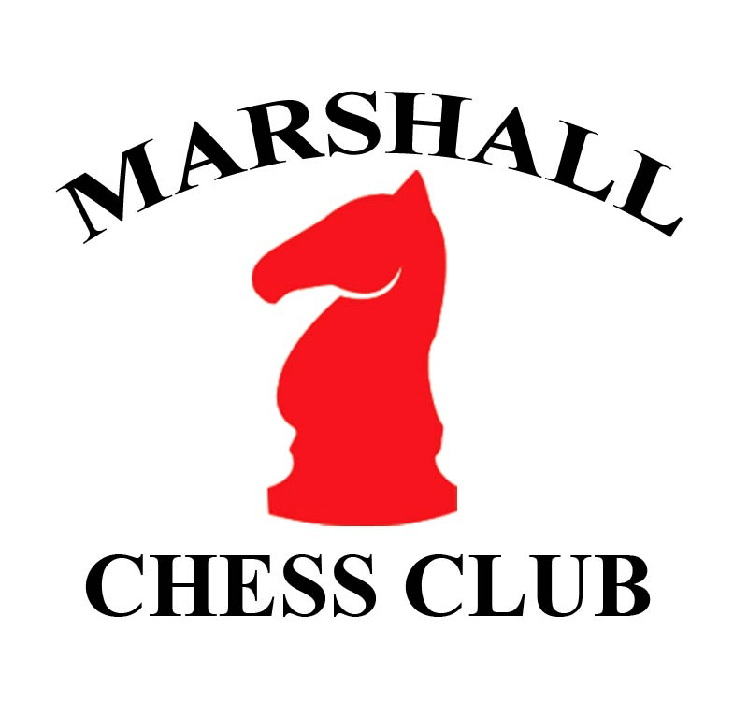
Marshall Chess Club
23 West 10th Street
New York, New York 10011
marshallchessclub.org

Training Member Application Form
Today’s Date
Membership Type | Training
Name
USCF ID
Email
Street Address
City, State, Zipcode
Telephone
Date of Birth
Emergency Contact
(Name & Phone)

I have read and agree to abide by the Marshall Chess Club Rules of Conduct.

Signature (applicant): ________________________________________________________

Signature (parent or guardian, if applicant is a minor): ______________________________

Training Membership
Training Members of the Marshall Chess Club are entitled to visit the club for workshops, to take lessons from approved teachers, and to attend club lectures and educational events.

Training Members do not receive additional membership benefits including: tournament discounts, class discounts, special event access, library access, and guest privileges.

For Office Use For Board Use
Date: New or Renewal:
Amount: Date of Approval:
Received by:
Circle Payment Method: Cash, Check or Credit Card

